Home learning grid for school closure EARLY LEVEL
Writing | Reading | Number
Go to https://bbc.in/2vgJ9CR Read the story book.  Make your own story book about a time you helped to cook. | Go to https://bbc.in/2TV2bHa Watch and read the poem “Fireworks at the Castle”.  It is a Scots language poem. 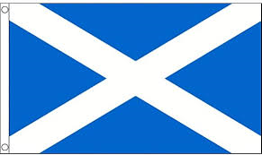 | 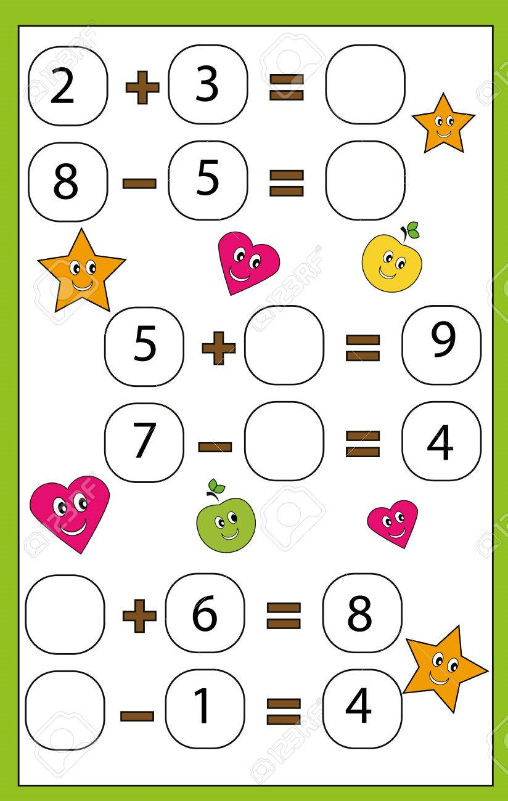
Spelling | Talking & Listening | Maths/Numeracy
Can you make new words using the letters in this word?  Elephant  I can make the word pan. | Ask an adult 5 questions about when they were little?  What did you find out? | 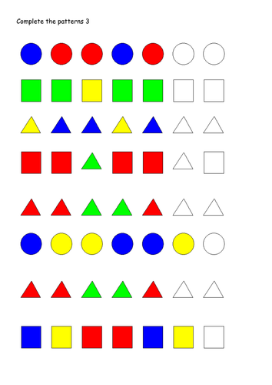
Something fun! | Problem to solve! | IDL Theme/Project
Go to https://bit.ly/2vf6J2H Play the movie (BUT CLOSE YOUR EYES)  Now draw the scene you listened to.  Now watch the movie with your eyes! | 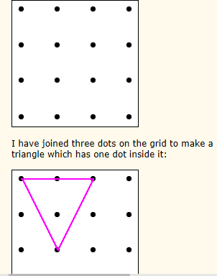How many triangles with one dot in the middle can you draw? | Write a food diary for the week. Write down or draw what you eat for  Breakfast  Lunch  Dinner  Snacks
Religious & Moral Education | Modern Languages | Art/Music/Drama/PE
Go to https://bit.ly/2IFxyAf Watch the story about Rama and Sita. Tell the story to someone else. | Go to https://bit.ly/2Q8lQlZ and learn the French song. | Go to https://bbc.in/2IFMH4L and play “One Tomato Two Tomatoes” Join in the songs.
Health & Wellbeing | Sciences/Technologies | Questions
Draw a picture showing each emotion.  Happy Sad Angry Scared | Count how many times you can jump up and down on the spot before you get tired. Do this in the morning, in the afternoon and at night. Is it the same number each time? Why? | Email address here

