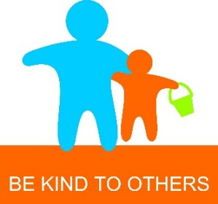
UNIT 9 Be Kind to Others

Family Sharing Activity
The children have been introduced to a concept called ‘Bucket Filling’ based around a book called ‘Have you filled a bucket today?’ by Carol McCloud. It is an easy-to-understand concept. Everyone carries an invisible bucket that fills up whenever we do kind, considerate, helpful things for others. We call these acts ‘bucket fillers’. When we say things that are mean, inconsiderate, uncaring, or disrespectful to others, this has a negative impact and gradually empties their and our buckets. These acts are bucket dippers.

We have learned that:
- Kindness makes a difference to ourselves and others
- Being unkind hurts others, and it hurts us too
- It is important to be kind to ourselves

Early Level (P1)
- Think about possible ways that you could fill your parents, friends or teachers’ buckets. Draw a picture of one of these ideas on the first bucket on the reverse of this sheet.

First Level (P2-P4)
- Think about possible ways that you could fill your parents, friends or teachers buckets. Write your ideas on the first bucket on the reverse of this sheet.

Second Level (P5-P7)
- Think about ways that you might make amends for dipping someone’s bucket. Share your ideas on the bucket on the second bucket on the reverse of this sheet.

Please return your family sharing activity to school so you can share your ideas with your class. Some examples will be chosen to share at our Sharing Assembly.

